Exp No:1.a Analyze the trend of data science job postings over the last
Decade
Code:
import pandas as pd
import matplotlib.pyplot as plt
data = {'Year': list(range(2015, 2026)),
'Job Postings': [500,650,600,800,1100,950,1500,2200,3100,3800,4500]}

df = pd.DataFrame(data)
plt.plot(df['Year'], df['Job Postings'], marker='o')
plt.title('Trend of Data Science Job Postings')
plt.xlabel('Year')
plt.ylabel('Number ofJob Postings')
plt.show()
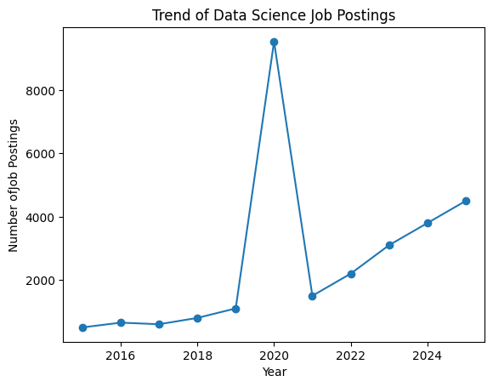

Exp No:1.b Analyze and visualize the distribution of various data science roles (Data
Analyst, Data Engineer, Data Scientist, etc.) from a dataset.
Code:
roles = ['Data Analyst', 'Data Engineer', 'Data Scientist', 'ML Engineer',
'Business Analyst']
counts = [420, 550, 380, 210, 190]
plt.bar(roles, counts)
plt.title('Distribution of Data Science Roles')
plt.xlabel('Role')
plt.ylabel('Count')
plt.show()
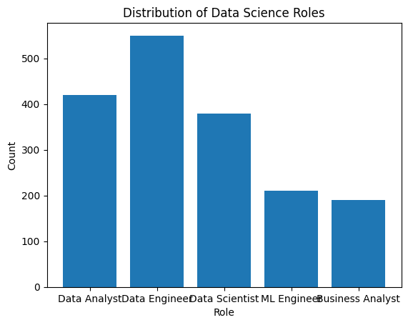
Exp No:1.c Conduct an experiment to differentiate Structured , Un-structured and Semi
structured data based on data sets given.
Code:
import pandas as pd
structured_data = pd.DataFrame({
'ID': [1, 2, 3],
'Name': ['Alice', 'Bob', 'Charlie'],
'Age': [25, 30, 35]
})
print("Structured Data:\n", structured_data)

# Unstructured data example
unstructured_data = """This is an example of unstructured data. It can be a piece of text, an image,
or a video file."""
print("\nUnstructured Data:\n", unstructured_data)

# Semi-structured data example (JSON)
semi_structured_data = {'ID': 1, 'Name': 'Alice', 'Attributes': {'Height': 165, 'Weight': 68}}
print("\nSemi-structured Data:\n", semi_structured_data)
Output:
Structured Data:
ID Name Age
0 1 Alice 25
1 2 Bob 30
2 3 Charlie 35

Unstructured Data:
This is an example of unstructured data. It can be a piece of text, an image,
or a video file.

Semi-structured Data:
{'ID': 1, 'Name': 'Alice', 'Attributes': {'Height': 165, 'Weight': 68}}
from cryptography.fernet import Fernet
key = Fernet.generate_key()
f = Fernet(key)
token = f.encrypt(b"Rajalakshmi Engineering College")
Exp No:1.d Conduct an experiment to encrypt and decrypt given sensitive data.
Description: Use the cryptography library to encrypt and decrypt a piece of data.
Code:
from cryptography.fernet import Fernet
key = Fernet.generate_key()
f = Fernet(key)
token = f.encrypt(b"Rajalakshmi Engineering College")
token
b'...'
f.decrypt(token)
b'Rajalakshmi Engineering College'
key = Fernet.generate_key()
cipher_suite = Fernet(key)
plain_text = b"Rajalakshmi Engineering College."
cipher_text = cipher_suite.encrypt(plain_text)
# Decrypt data
decrypted_text = cipher_suite.decrypt(cipher_text)
print("Original Data:", plain_text)
print("Encrypted Data:", cipher_text)
print("Decrypted Data:", decrypted_text)
Original Data: b'Rajalakshmi Engineering College.'
Output:
Encrypted Data: b'gAAAAABqqN4FIv1UPcryF0tzwMip-zAqjqH6FUNykU4nENQ5syEzYn5etJAxKPKrFT9lauoO_9Jbp2vCV3ZnGE7UTqzQKN4vvsyRXeeirOGdLpVCKIYJvUPaAiIeypWaYhEs-g5dkfn_'
Decrypted Data: b'Rajalakshmi Engineering College.'

